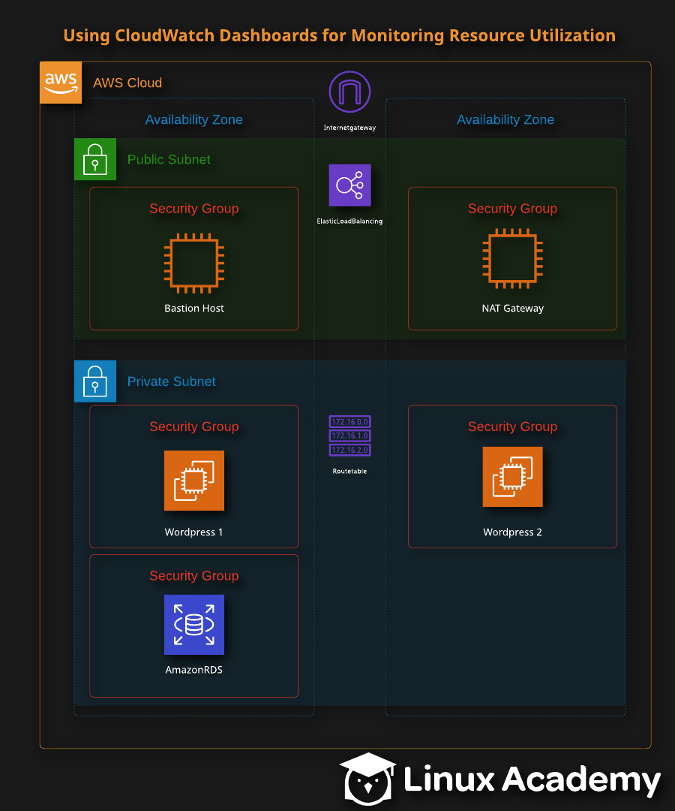
Your company has just issued a new requirement that all team members be more involved with cost savings while having the ability to monitor their applications. To increase the visiblity not only for your company teams (Development, Testing, Production, etc.) but also management and the finance teams, you have decided to create CloudWatch dashboards to monitor the reource allocation of your application to provide more insight into possible cost savings. Let's get started!!!
Go to the AWS Console using the link provided after lab creation is complete.
Log in using the credentials provided to you. You should have been given a user name of 'cloud_user' and a randomly generated password.
When you log in, please make sure you are in the us-east-1 region.

Using CloudWatch Dashboards to Monitor Resource Utilization
In this lab, we will create and configure multiple custom AWS CloudWatch dashboards and widgets to monitor our resource utilization and create two separate Cloud Watch dashboards to monitor the resource utilization of our application.

Before we Begin
Before we start the lab, use the credentials provided by Linux Academy to log into AWS. Here, you will find yourself on the AWS Management Console. When you log in, make sure you are in the N. Virginia region. You can check this by looking next to the Support dropdown. If you are not, change your location to the N.Virgina region.

How to Use Cloud Watch Dashboards for Monitoring Resource Utilization
Now that we're logged in, we can start working on our dashboards for CloudWatch.

Create a Custom CloudWatch Dashboard
To create a CloudWatch dashboard, go to the Services dashboard. Under the Management & Governance section, select CloudWatch. Here, select Dashboards, then Create dashboard.
We want to name this dashboard BHCPUutilization. Once you've added in the name, select Create Dashboard. You will then be prompted to add a widget. We want to add a Line widget. Once chosen, select Configure.
Now, we need to add a metric for the dashboard. To do that, select EC2, then Per-InstanceMetric. Here, search for CPUUtilization, and then select the Bastion Host. At the top of the page, select the custom dropdown, and set the time interval to 15 in the minutes section. After you've set the time, click Create Widget and then select Save Dashboard.

Create the Second Custom Dashboard
Now, we need to make our second dashboard. Once again, in the CloudWatch console, select Dashboards. SelectCreate dashboard, and name it APPCPUutilization. Now, click Create Dashboard. This time, select the Stacked widget. Again, add the metric for EC2, and select Per-InstanceMetric. Search for CPUUtilization. Select the following instances:
- database
- instance-wordpress
- instance-wordpress
With those selected, set the custom time interval to 15 minutes once again. Now select Create Widget and then Save Dashboard.

Add Additional Widgets to the Custom Dashboard
Now that we've created our two dashboards, and provided them both with widgets, we need to create a widget for an already created dashboard. To do this, on the desired dashboard (for now, let's use the one we just made), select Add widget from the top of the page. This time, let's select the Number Widget. For the metric, select Application ELB, then Per AppELB Metrics, and select the metrics named RequestCount. Finally, select Create Widget and then Save Dashboard.
Now we need one more widget. Again, select Add Widget, and then this time select Line. For the metrics, select EC2, Per-Instance Metrics, search for NetworkIn, and then select the two wordpress EC2 instances and our database instance. Create the widget and then save the dashboard.

Generate Traffic
With our dashboards created, we now want to generate some traffic for these dashboards. To do so, go to the EC2 Dashboard and then, under Load Balancing, select Load Balancers.
Copy the DNS Name and then post it into a new tab of our preferred web browser. We are taken to our WordPress site. Select your desired language and then Continue. Fill in the information as:
- Site Title: Labdemo
- Usrename: LAuser
- Password: (Whatever we want)
- Your Email: The email you wish to use for this lab
Now, select Install Wordpress. Using the user name and password, log into WordPress. Wonderful, we're able to use WordPress.
Go back to the CloudWatch dashboard. Under Management & Governance select CloudWatch. On the next page, select Dashboards. Select the first dashboard. Here, we should see information has started to populate our widgets, which tells us that we have set up everything correctly.

Conclusion
Upon completing this lab, we are now able to create CloudWatch dashboards and widgets, and test and make sure that they are working correctly. Congratulations on finishing this lab!

